**Week 1**

**Welcome**

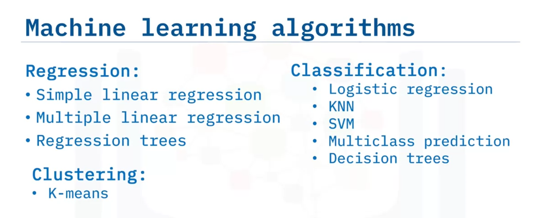

**What is Machine Learning?**

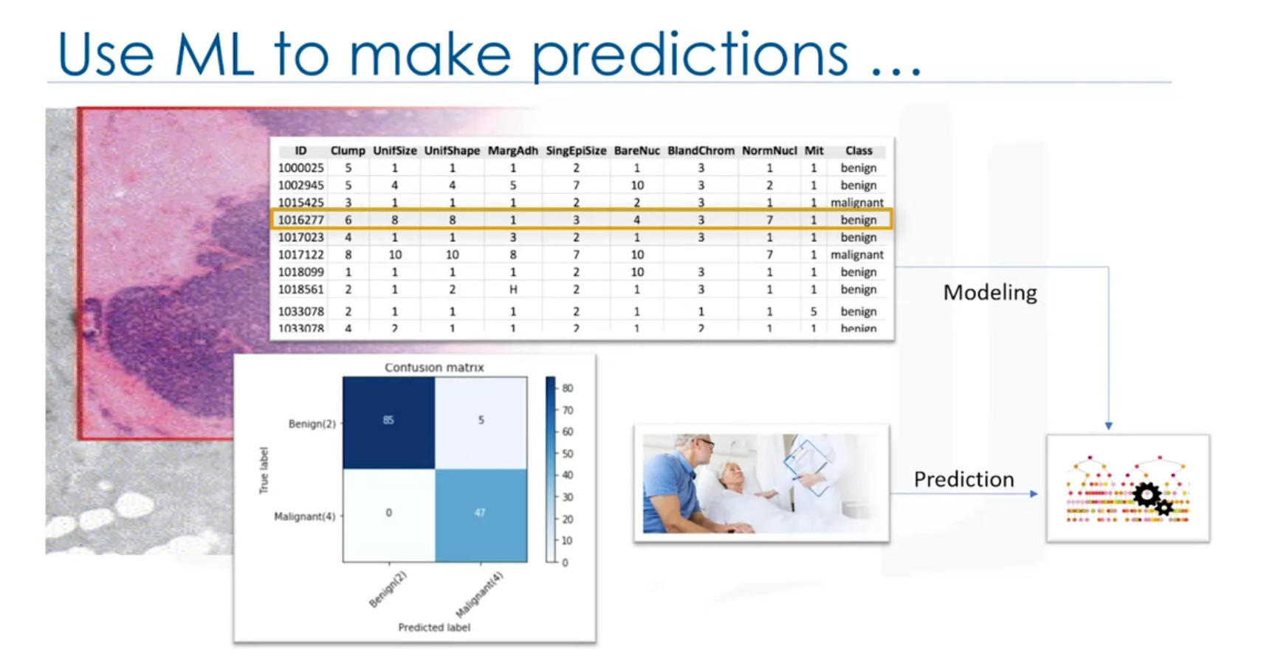

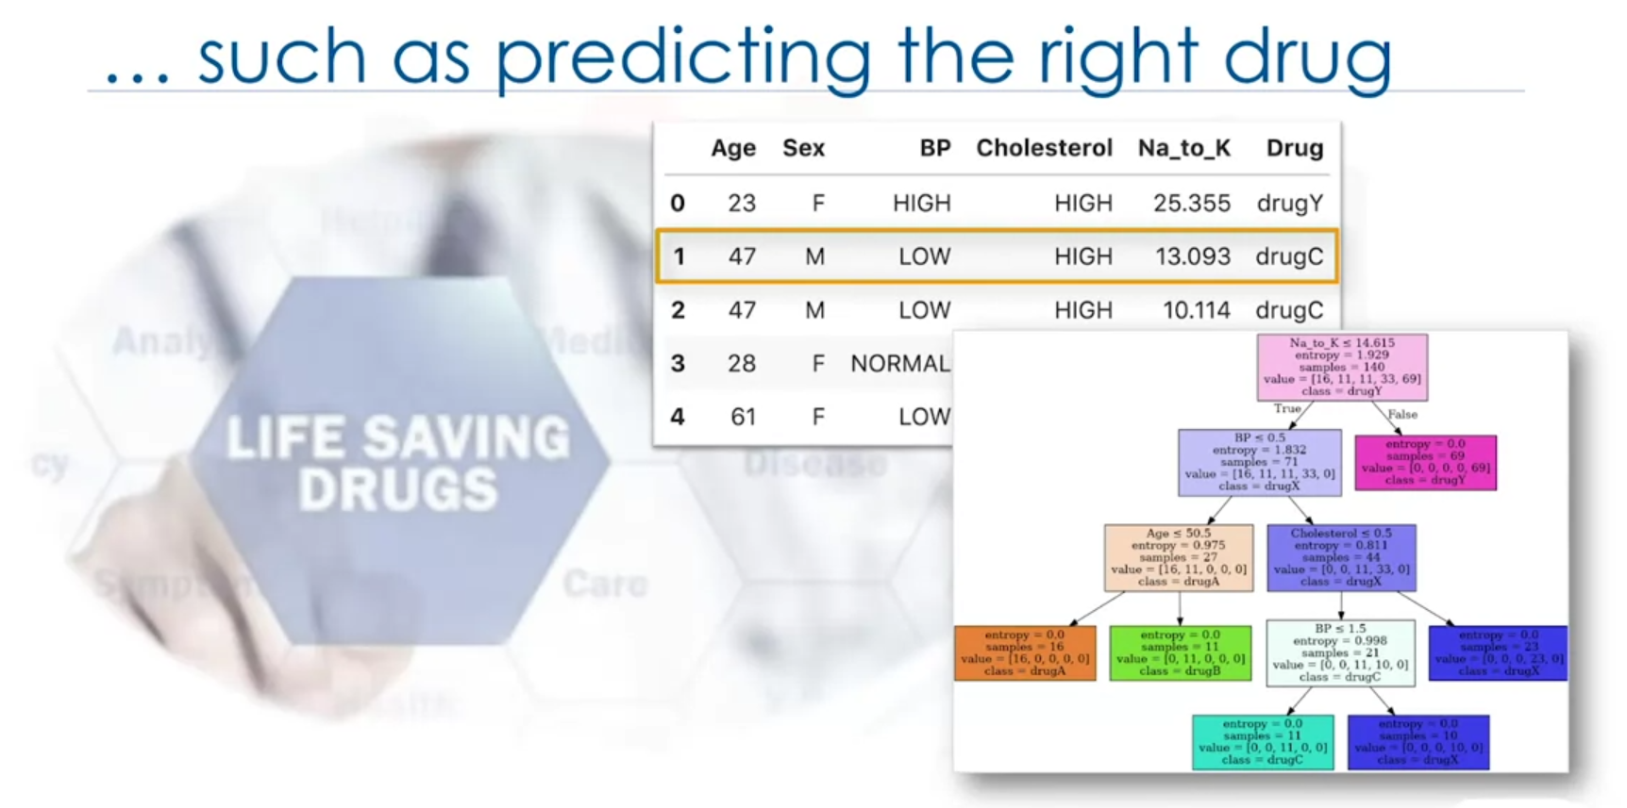

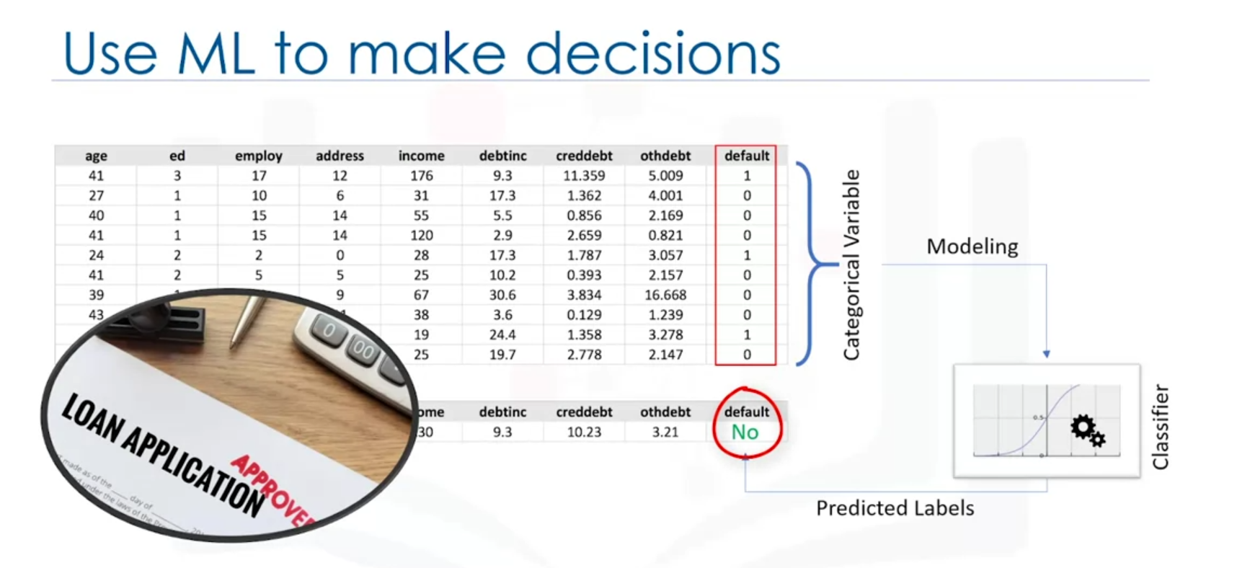

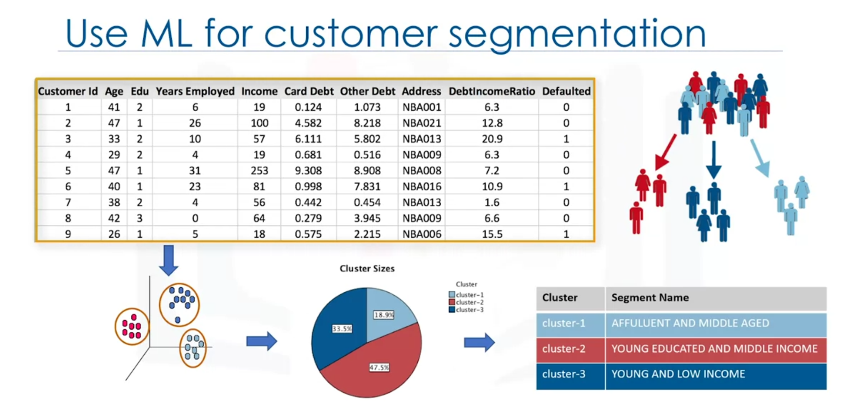

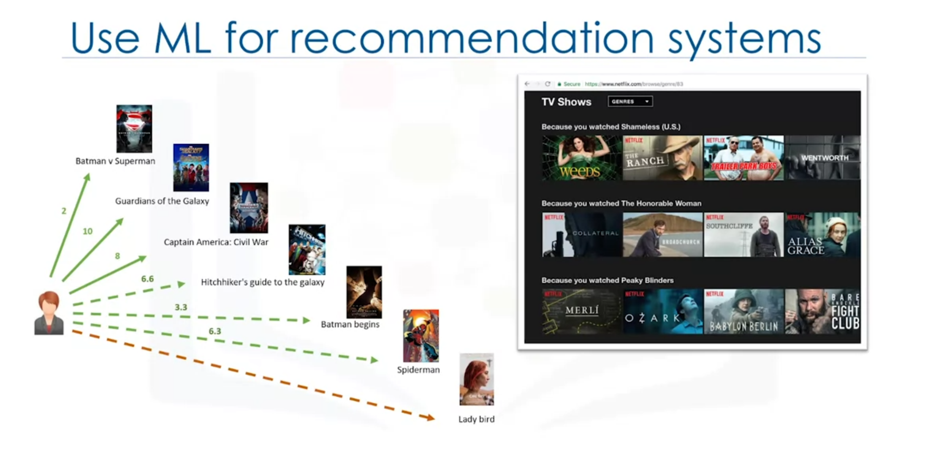

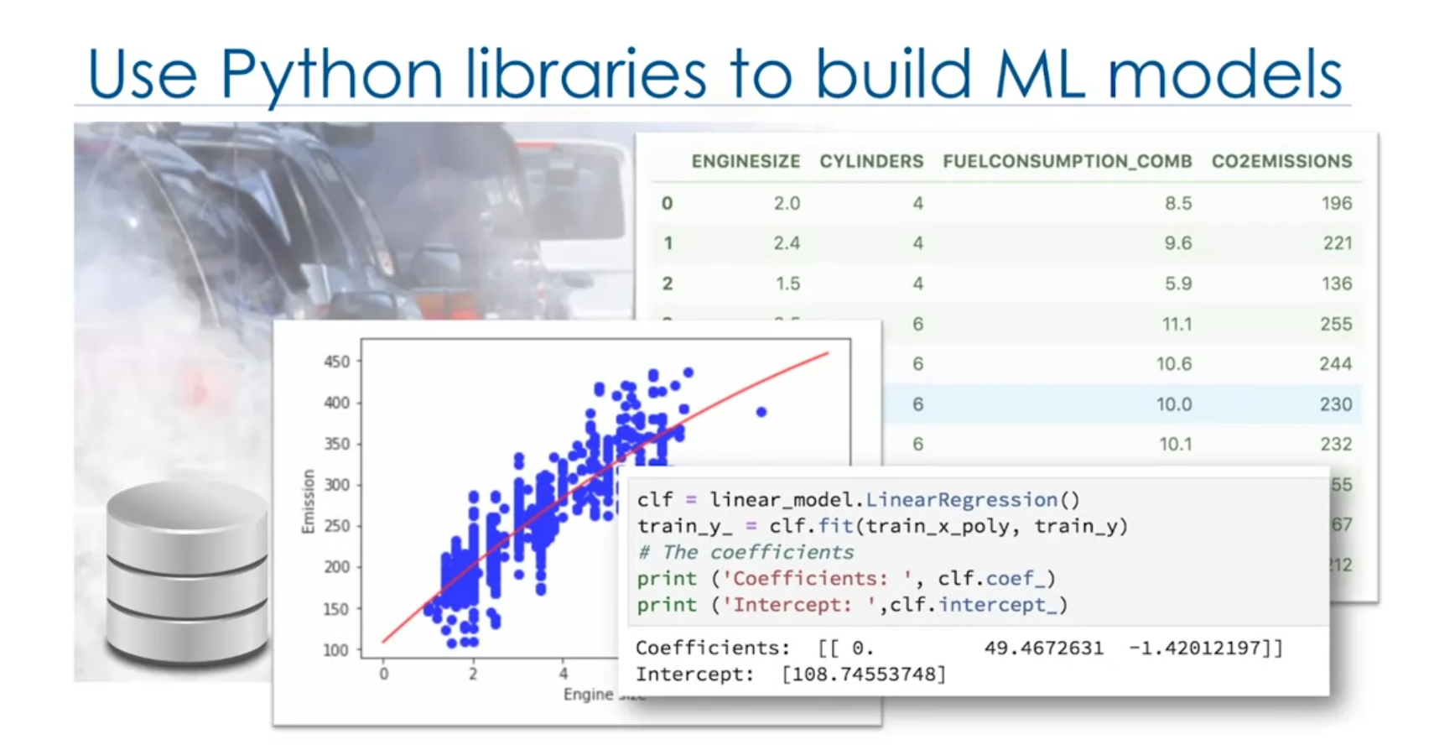

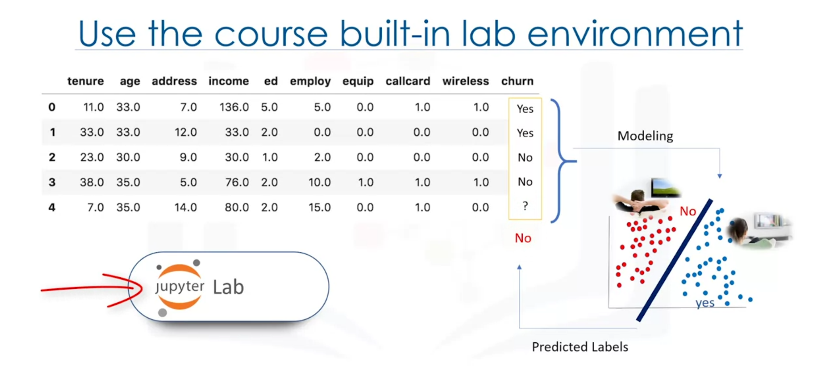

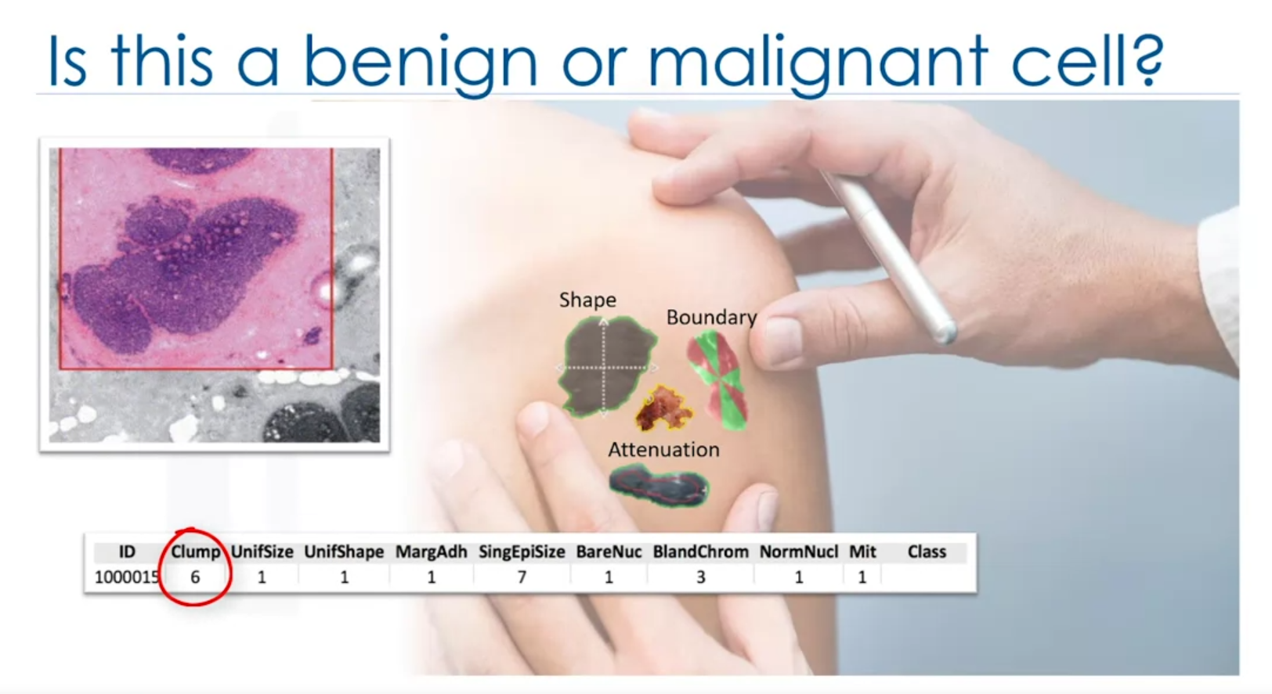

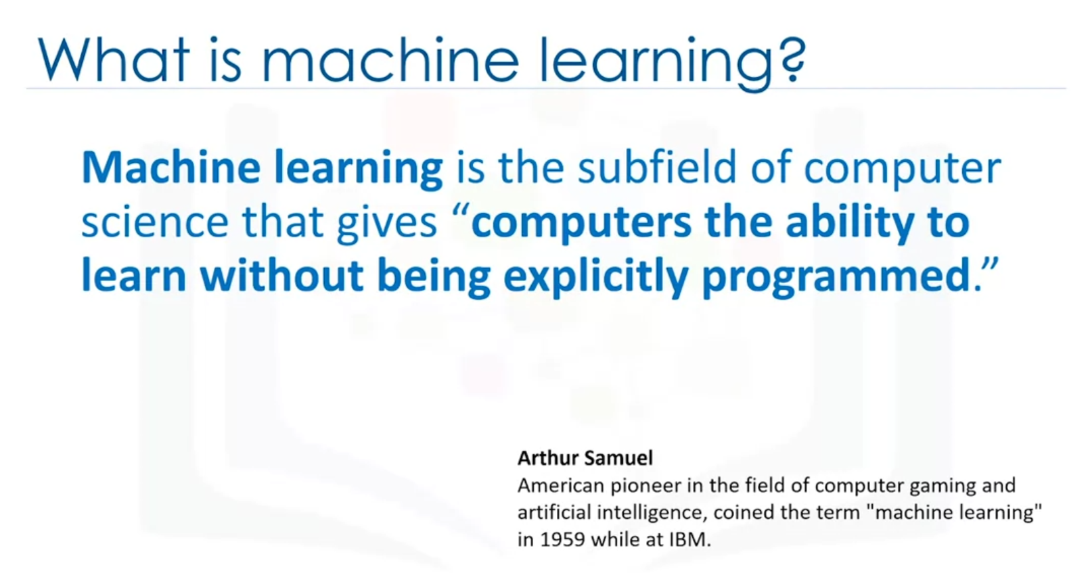

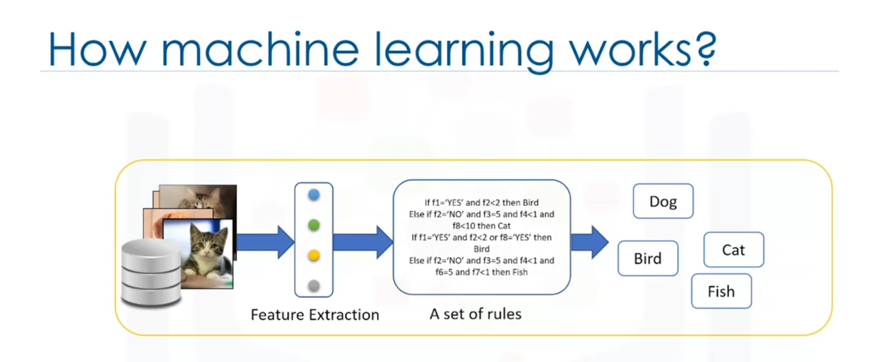

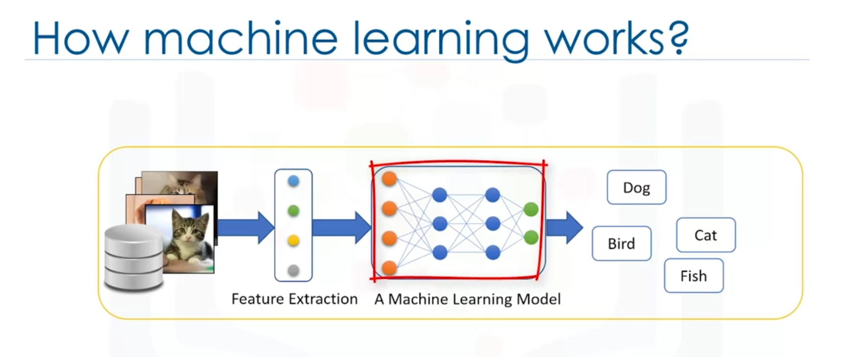

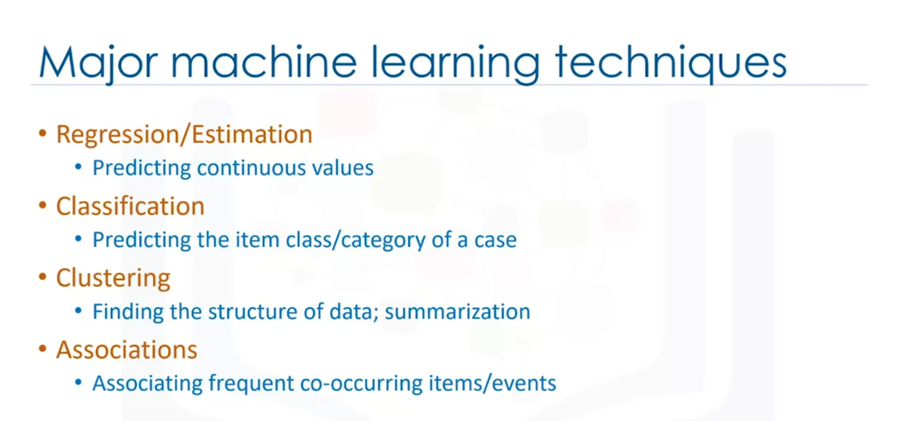

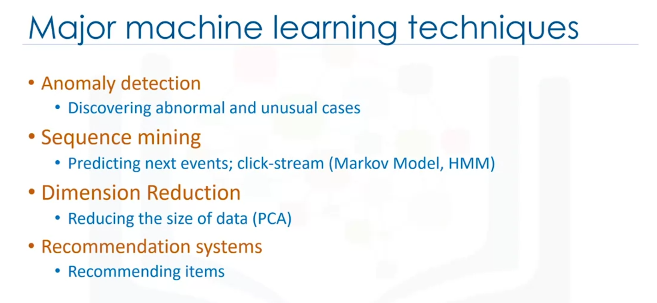

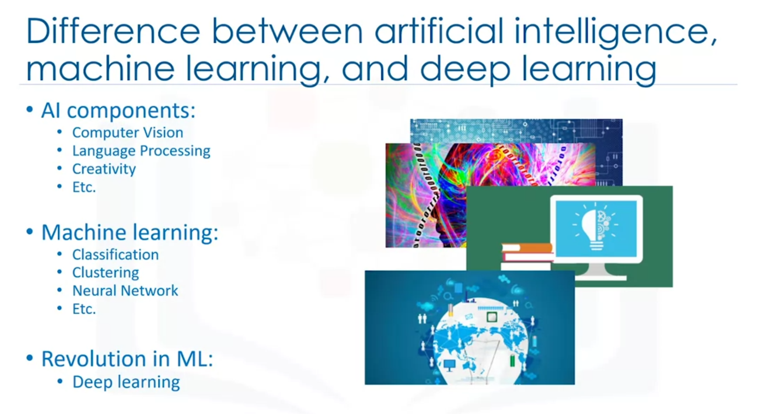

* In brief, **AI** tries to make computers intelligent in order to mimic the cognitive functions of humans. So, Artificial Intelligence is a general field with a broad scope including: Computer Vision, Language Processing, Creativity, and Summarization.
* **Machine Learning** is the branch of AI that covers the statistical part of artificial intelligence. It teaches the computer to solve problems by looking at hundreds or thousands of examples, learning from them, and then using that experience to solve the same problem in new situations.
* And **Deep Learning** is a very special field of Machine Learning where computers can actually learn and make intelligent decisions on their own. Deep learning involves a deeper level of automation in comparison with most machine learning algorithms.

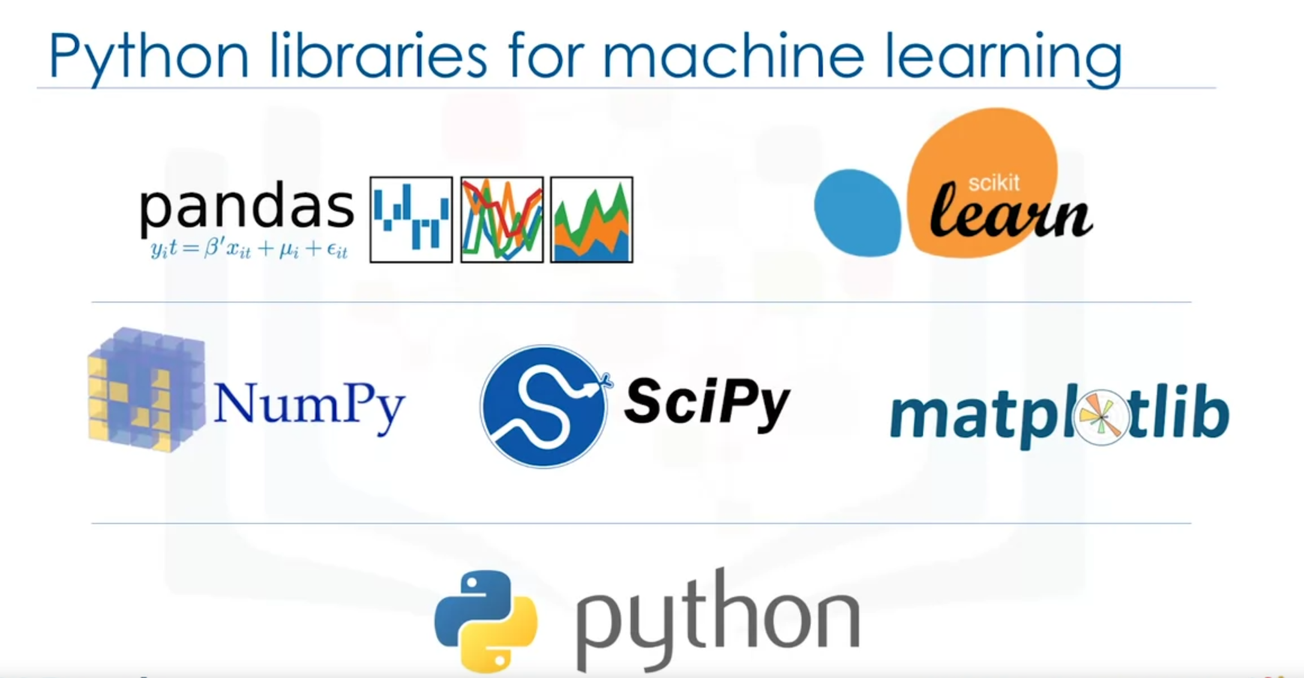

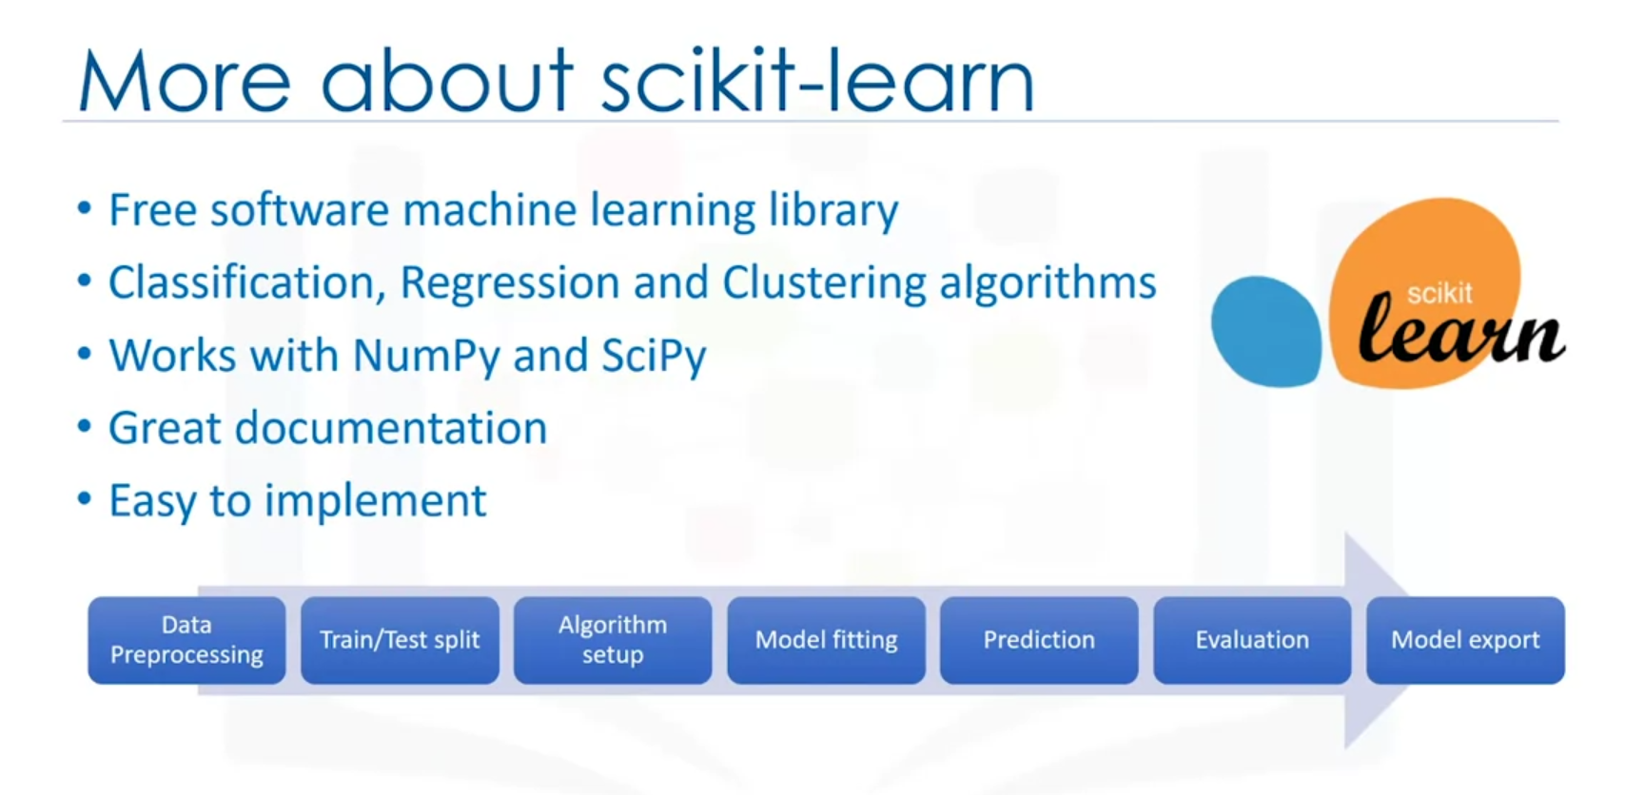

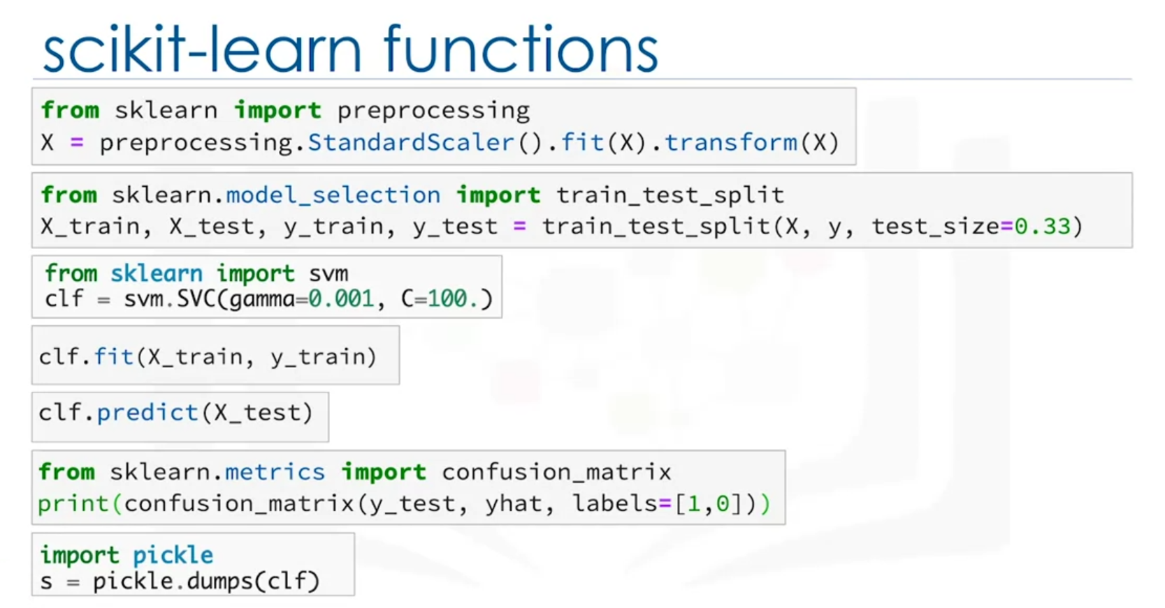

The most important point to remember is that the entire process of a machine learning task can be done simply in a few lines of code using SciKit Learn. Please notice that though it is possible, it would not be that easy if you want to do all of this using NumPy or SciPy packages. And of course, it needs much more coding if you use pure Python programming to implement all of these tasks.

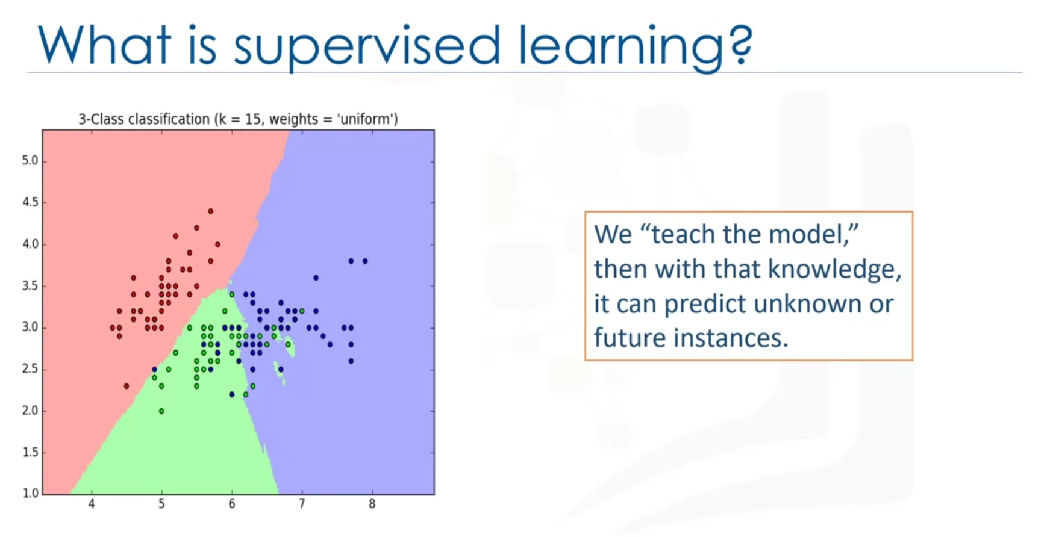

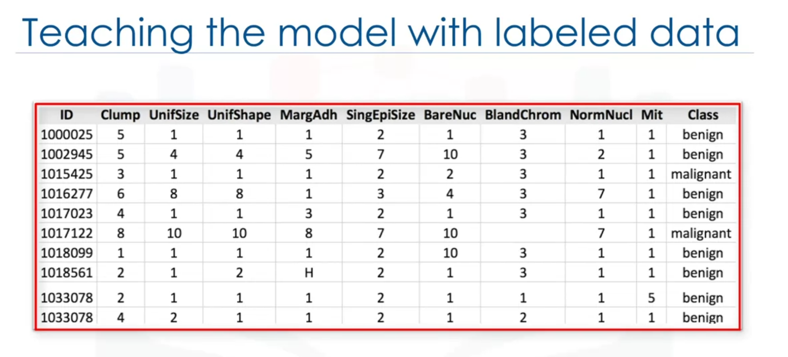

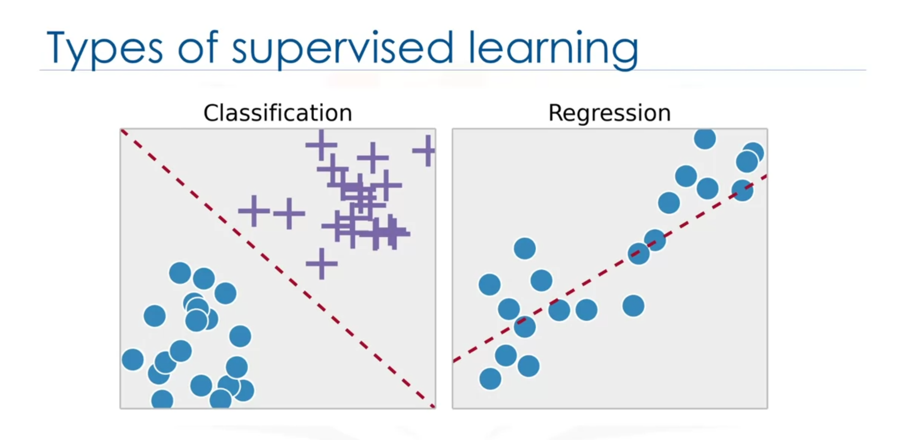

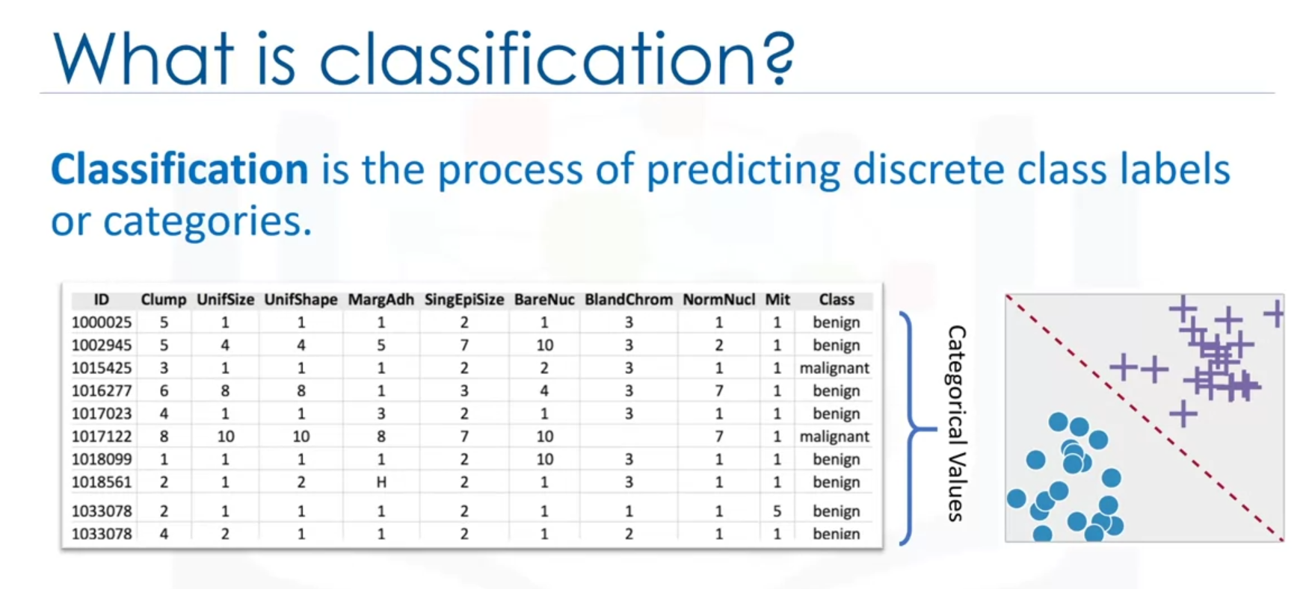

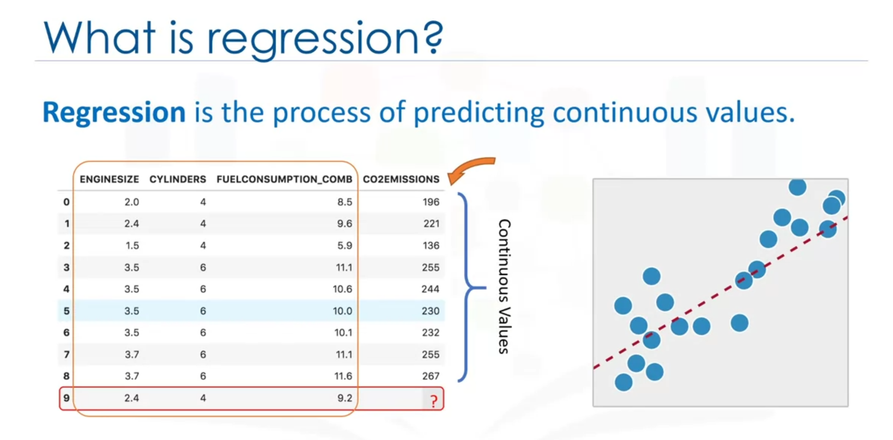

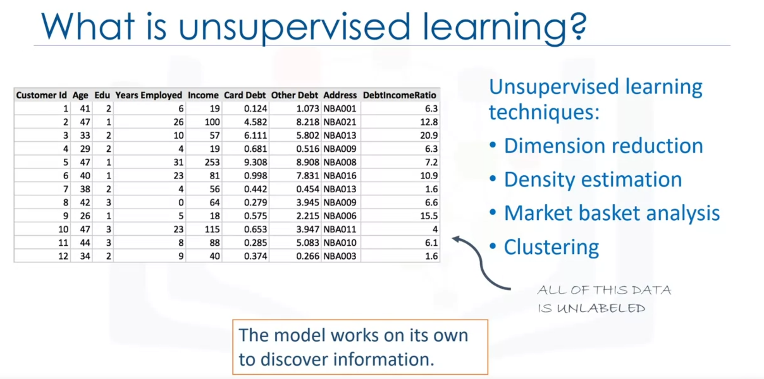

* **Dimensionality reduction**, and/or feature selection, play a large role in this by reducing redundant features to make the classification easier.
* **Density estimation** is a very simple concept that is mostly used to explore the data to find some structure within it.
* **Market basket analysis** is a modeling technique based upon the theory that if you buy a certain group of items, you're more likely to buy another group of items.
* **Clustering** is considered to be one of the most popular unsupervised machine learning techniques used for grouping data points, or objects that are somehow similar.

